Contents
1. Tracking changes to document templates 2
A: Creating a new mail merge document template 2
2. Merge fields 2
3. Macros 5
4. Margins 9
5. Create a new template in the Portal 9
6. Testing 13
7. Viewing Template settings 14
8. 'Email From' Configuration 14
9. Removing Templates 15
B: Updating an existing document template 15
10. Editing the Word template 15
11. Uploading an amended template 15
12. Amending templates in the Portal 16
13. Archiving a document template. 17
14. Maintaining the Change-Update Requests log 17
Adding Security Options (optional - not currently in use) 18
C: Raising a change request 18
15. New or amended document template 18
16. New or amended letterhead 19
D: Resolving issues within the templates 21
17. Department header appearing on every page 21
18. Extra spacing between rows or paragraphs 21
19. No spacing between paragraphs 22
20. Department header not appearing 22
21. Prompts, Fill-ins and merge fields 23
22. Prompt does not appear as expected 23
23. ASK response does not return data as expected 23
D: Creating or amending departmental letterheads 23

Document Version Control
Change History/Review Details
Date | Version | Review by | Summary of Change
15jun17 | 0.1 | HC | Draft Created
25 Aug 17 | 0.2 | HC | Updated to include guidance re pages and header/footer margins
28Feb18 | 0.3 | HC | Updated to include troubleshooting
May/Jun18 | 0.4 | HC | Updated following a change to the process for editing current documents
Sep19 | 0.5 | HC | Updated to include latest guidance from CoreHR
Dec19/Jan20 | 0.6 | HC | Updated to reflect move of Recruitment to the Portal
Oct20 | 0.7 | HC | Updated to reflect the move to V28

Knowledge Article - Letter and Email Templates Knowledge Article v0.3.docx

Other Related Documents

- Standard Asks and Prompts (draft)

Overview
All templates are currently saved under:

\\connect.ox.ac.uk\ADMN\PS\HRIS\Core correspondence templates

 | NB: When opening any letter templates from this folder, the security message below is displayed. Ensure that the X is selected (i.e. close the message) and DO NOT click on the Enable Content button.  If Enable Content is selected then formatting in the template will be compromised.

New document templates could be a candidate for a Standard Change, but one has not yet been set up.

Tracking changes to document templates
All changes to letter templates should also be recorded in the Change updates request to Core templates log.xls found in O:\PS\HRIS\Core correspondence templates.

A: Creating a new mail merge document template

Merge fields
 | NB: Ensure you have the most recent merge fields. If in doubt download the latest data sources from the Portal.

- Open the document template and select  Mailings > Start Mail Merge > Step by Step Mail Merge Wizard. | 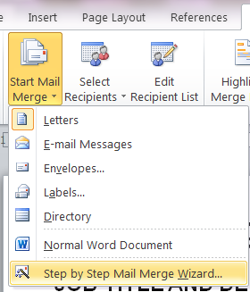

- Go to Step 2 and select ‘Next: Select recipients’ |  | 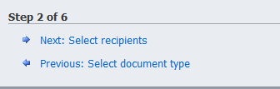
- Select ‘Browse’ and navigate to the Data Source folder and select the relevant data source. |  | 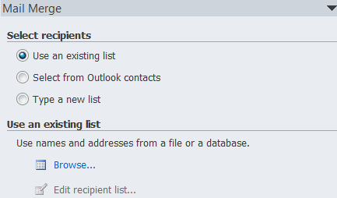  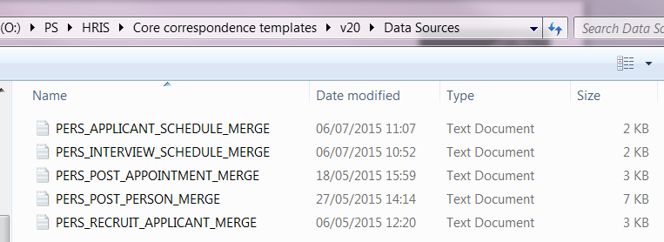
- Select (or enter) a “|” (pipe) symbol in the Field delimiter field and leave the Record delimiter as the default (enter).  - Click OK |  | 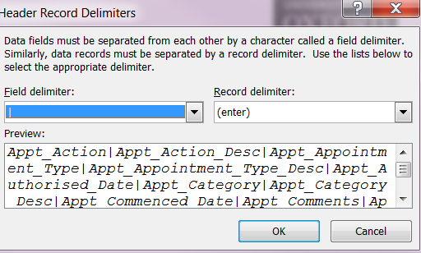
- In the Mail Merge Recipients screen ensure both rows are selected and click OK. | 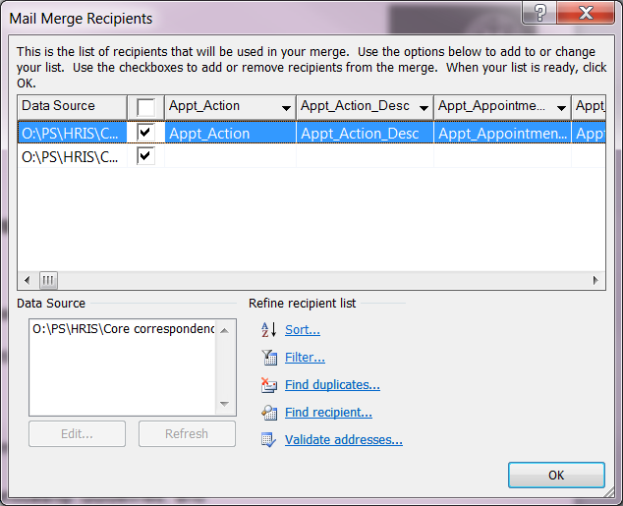
- You will now be able to select the mail merge fields required for use in your template.  - Select each merge field as required. | 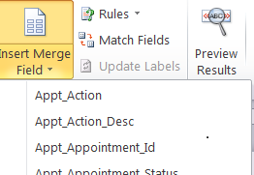

Note: CoreHR recommend that merge fields are selected each time, rather than copying them from another template.

Macros
Macros have been added to each word template to carry out the following:

  - Add Departmental header and footer from another document.

  - Enable automatic display of Fill-in prompts to the end user (e.g. to enable the population of certain fields within the letter).

  - Allow the user to create a standard text document from the template letter, which can then edited (see below for more detailed information on each Macro).

Macros can be found in the following folder O:\PS\HRIS\Core correspondence templates\v20\Macros\New Macros from 30OCT15.

 | NB. During the first run of this macro, a variable named “macruncorexx” is created and set with a value of 1. Variables are set against a Word document, so once set will remain each time the document is opened. This stops the macro running if the document is re-opened; this will allow users to edit and save changes to the document.

  - When the macro is run it carries out the following:

- Opens the first page header and copies the header information from the area bookmarked “header1” from a letterhead document held in C:\Coreapps\Letter_head.docx on the user’s PC (see section on Department Letterheads).

- Copies the footer information from the area bookmarked “foot3” from the same document.

- Selects the entire document and performs a Ctrl+A, then F9 keyboard action; this causes the Fill-in prompts to be displayed for the user to complete.

- Selects all text and removes all mail merge fields (e.g. ifs and fill-ins etc.) to leave only plain text in the document.

  - The Macro is named AutoOpen in each template. Macros can be accessed in Word from View>Macros button>Edit macro.

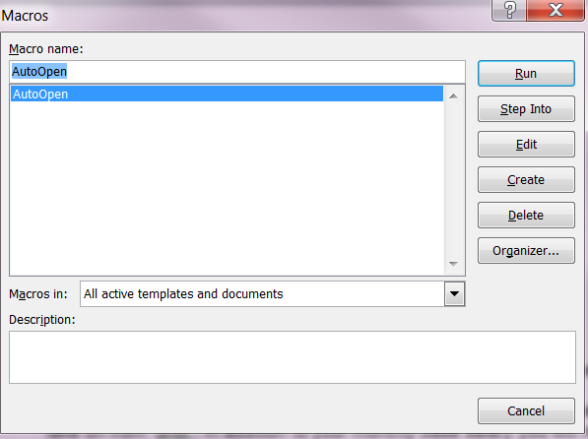

  - There are two macros to choose from depending on whether a Departmental letterhead is required: one pulls through the letter head/footer information and the Fill-in prompts and the other only enables the Fill-in prompts. The name of the Macro should always be AutoOpen.

  - New Macro Fill-ins only – this macro is used if the template is NOT output on departmental letterhead stationery:

Sub AutoOpen()
'''Sub AutoOpen() is the name of any macro that runs when a word document opens.
'''All macro information needs to be entered between Sub AutoOpen() and End Sub
Dim strVal as Long
'''The above just tells word that strVal is a number, as opposed to text.
'''during the first run of this macro a variable called macruncorexx is created and set with a value of 1
'''variables are set against a word document so once set will remain each time the document is opened
'''the existence of macruncorexx and value of macruncorexx is checked by the first piece of code in the macro to establish if the macro has been run before
'''the following code sets strVal as the value of macruncorexx if it exists
'''if macruncorexx does not yet exist then strVal is set as 0 to tell word that the macro has not yet been run
On Error Resume Next
strVal = ActiveDocument.Variables("macruncorexx").Value
If Err.Number <> 0 Then
strVal = 0
End If
On Error GoTo 0 ' reset error handler

'''the macro then only continues if the strVal (taken from the value of macruncorexx if it exists) is not 1
If strVal <> 1 Then

'''you must then add any specific macro within this space
'''select all of the document of forces the prompts to be displayed
Selection.WholeStory

Selection.Fields.Update
Selection.MoveUp Unit:=wdLine, Count:=1

'''end specific macro space

'''after any specific macro has been run the following code will set macruncorexx as 1 to tell the macro not to run again next time
ActiveDocument.Variables.Add Name:="macruncorexx", Value:=1
'''the following three rows of code removes all mail merge fields (e.g. ifs and fill-ins etc.) to leave only plain text in the document
Selection.WholeStory
Selection.Fields.Unlink
Selection.HomeKey Unit:=wdStory
'''the end if below indicates the end of all of the things the macro should do the first time it is run
End If

end sub

  - New macro letterhead and Fill-ins – this macro is required if the letter is output on departmental letter head stationery:

Sub AutoOpen()
'''Sub AutoOpen() is the name of any macro that runs when a word document opens.
'''All macro information needs to be entered between Sub AutoOpen() and End Sub

Dim strVal as Long
'''The above just tells word that strVal is a number, as opposed to text.

'''during the first run of this macro a variable called macruncorexx is created and set with a value of 1
'''variables are set against a word document so once set will remain each time the document is opened
'''the existence of macruncorexx and value of macruncorexx is checked by the first piece of code in the macro to establish if the macro has been run before

'''the following code sets strVal as the value of macruncorexx if it exists
'''if macruncorexx does not yet exist then strVal is set as 0 to tell word that the macro has not yet been run
On Error Resume Next
strVal = ActiveDocument.Variables("macruncorexx").Value
If Err.Number <> 0 Then
strVal = 0
End If
On Error GoTo 0 ' reset error handler

'''the macro then only continues if the strVal (taken from the value of macruncorexx if it exists) is not 1
If strVal <> 1 Then

'''you must then add any specific macro within this space

' Auto open Macro

If ActiveDocument.Sections(1).Headers(wdHeaderFooterFirstPage).Range.Text = Chr(13) Then

If ActiveWindow.View.SplitSpecial <> wdPaneNone Then
ActiveWindow.Panes(2).Close
End If

If ActiveWindow.ActivePane.View.Type = wdNormalView Or ActiveWindow. _
ActivePane.View.Type = wdOutlineView Then
ActiveWindow.ActivePane.View.Type = wdPrintView
End If

ActiveWindow.ActivePane.View.SeekView = wdSeekCurrentPageHeader
Selection.InsertFile FileName:="C:\Coreapps\Letter_head.docx", Range:="header1", _
ConfirmConversions:=False, Link:=False, Attachment:=False
ActiveWindow.ActivePane.View.SeekView = wdSeekMainDocument

' footer
ActiveWindow.ActivePane.View.SeekView = wdSeekCurrentPageFooter
Selection.InsertFile FileName:="C:\Coreapps\Letter_head.docx", Range:="foot3", _
ConfirmConversions:=False, Link:=False, Attachment:=False
If ActiveWindow.View.SplitSpecial <> wdPaneNone Then
ActiveWindow.Panes(2).Close
End If
If ActiveWindow.ActivePane.View.Type = wdNormalView Or ActiveWindow. _
ActivePane.View.Type = wdOutlineView Then
ActiveWindow.ActivePane.View.Type = wdPrintView
End If
ActiveWindow.ActivePane.View.SeekView = wdSeekCurrentPageHeader
Selection.EscapeKey

' select all of the document
Selection.WholeStory

Selection.Fields.Update
Selection.MoveUp Unit:=wdLine, Count:=1

End if

'''end specific macro space

'''after any specific macro has been run the following code will set macruncorexx as 1 to tell the macro not to run again next time
ActiveDocument.Variables.Add Name:="macruncorexx", Value:=1
'''the following three rows of code removes all mail merge fields (e.g. ifs and fill-ins etc.) to leave only plain text in the document
Selection.WholeStory
Selection.Fields.Unlink
Selection.HomeKey Unit:=wdStory
'''the end if below indicates the end of all of the things the macro should do the first time it is run
End If

end sub

How to make the answer to a FILLIN prompt repeat elsewhere in the document, without needing to repeat the FILLIN prompt itself.

  - The FILLIN prompt needs to be wrapped in another set of brackets with the words ‘SET’ and the reference of your choice given after for the prompt/answer, e.g.

{ SET TheName { FILLIN “Please write your name” } }

In order for the answer to then appear in the text, simply insert { TheName } wherever you wish the answer to this prompt to appear.

Margins
There are two areas that you may need to review which will determine where the text, headers and footers on the departmental letterheads will appear. In addition to the standard page margin settings, there are also settings to determine how far down the page the header is set and how far up the page the footer is set.

  - To review the Header/Footer settings, click into the header or footer in the template document and go to the DESIGN Tab.

  - Under Position, review the ‘Header from Top’ setting and the ‘Footer from bottom’ setting.

  - University standard letterhead settings are:

Header from top 1.3 cm  Footer from bottom 1.0 cm | 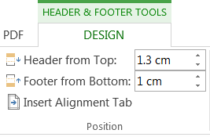

Create a new template in the Portal
People Management>Data Centre>HR Admin Setup and Settings>Document and Email Templates

The Template Configuration Centre opens:
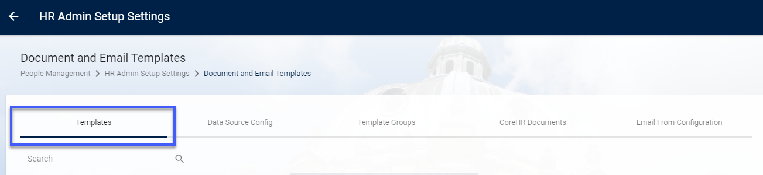

There are various tabs within the Configuration Centre.

Templates
This is where the existing template documents are stored and can be edited or deleted. New templates can also be created here.

Data Source Config
The purpose of this section is not clear. It does not display the full list of merge fields but contains some config which again is not clear. (Update this section once more is known)

Template Groups
A summary of the existing template groups can be viewed here including the number of document and email templates within each group. New groups can also be created if required.

CoreHR Documents
This contains a list of pre-existing default Documents. We use some but not all of these. Further details can be found in the knowledge article

‘Email From’ Configuration
From here it is possible to configure the 'From' addresses that appear on email notifications.

 | NB: Templates created in the Portal cannot be generated in the Back Office.

5.2. Create a new document template

    - Click on Create Document Template under ACTIONS

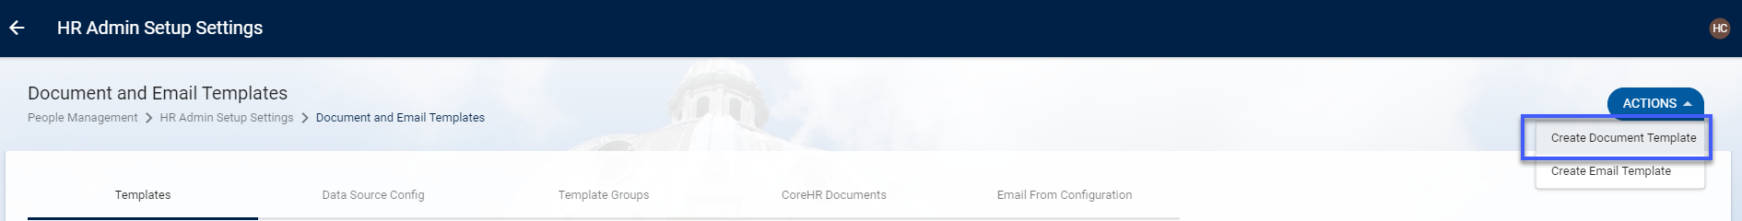

A blank 'Create Document Template' window opens:

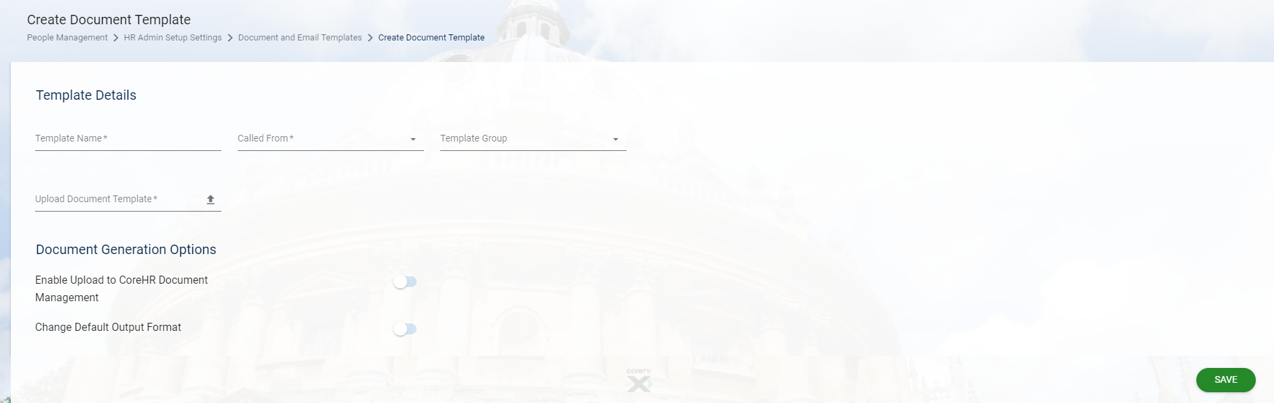

    - Select/update as required:
Field Name | Action
Template Name* | Enter a title for your document
Called From* | Select either 'View Applicants' or 'Employee Dashboard' as applicable
Template Group* | Select 'Recruitment' or 'Post Appointments' as applicable.
Upload Document Template* | Browse and select the relevant template
Enable Upload to CoreHR Document Management  **See note below | OFF (default)
Change Default Output Format | OFF (default)

 | Note: If in the future we decide to upload documents to the applicant or employee record, this option will need to be enabled here for every document.

    - SAVE

5.3 Create a new email template

    - Click on Create Email Template under ACTIONS

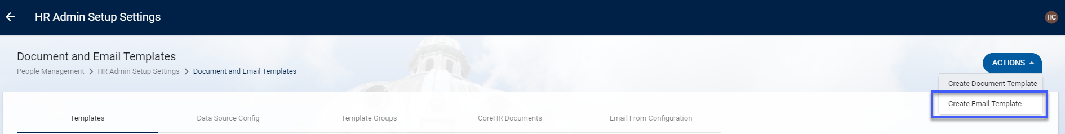

A blank Create Email Template screen will open:
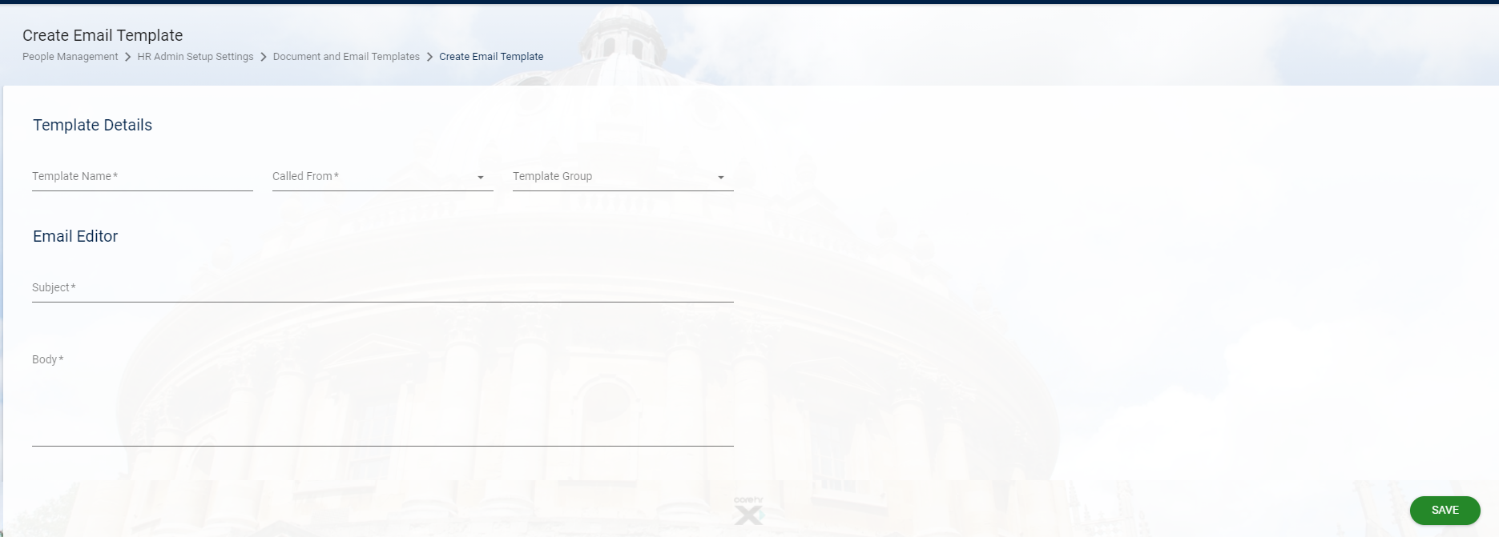

    - Complete each field as follows:
Field Name | Action
Template Name* | Enter a title for your email
Called From* | Select either 'View Applicants' or 'Employee Dashboard' as applicable
Template Group* | Select 'Recruitment' or 'Post Appointments' as applicable.
Data View Source* | Should default in but check that it is as expected   Appears when ‘Called From’ is selected
Subject* | Enter a subject for your email, including any merge fields required
Body* | Enter the email text, including any merge fields

    - To insert a merge field, place your cursor where you want the text to appear. Select or search for the field from the list on the right-hand side. Click once on the required field to insert.

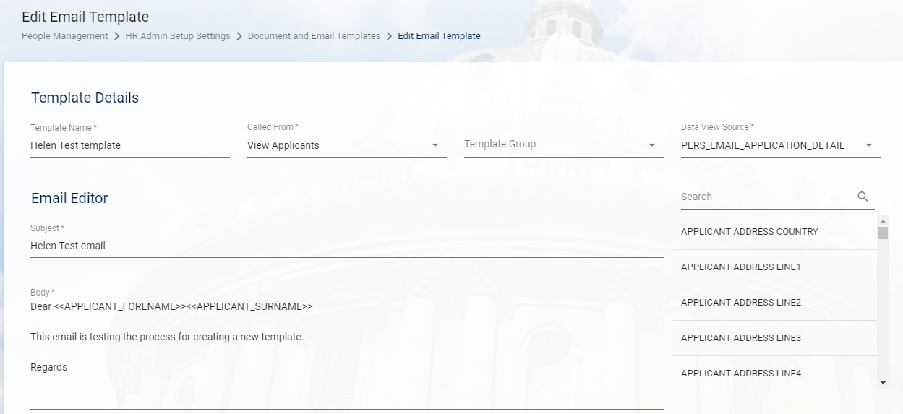

    - Enter search criteria to filter the list.

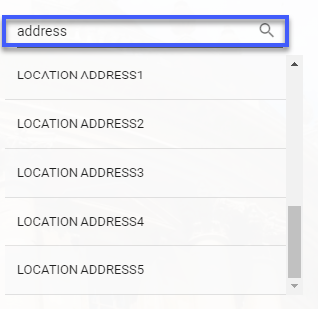

    - SAVE

A pop-up message will appear confirming that the template has been created successfully.

Your new template will now be available to select from the specified screen.

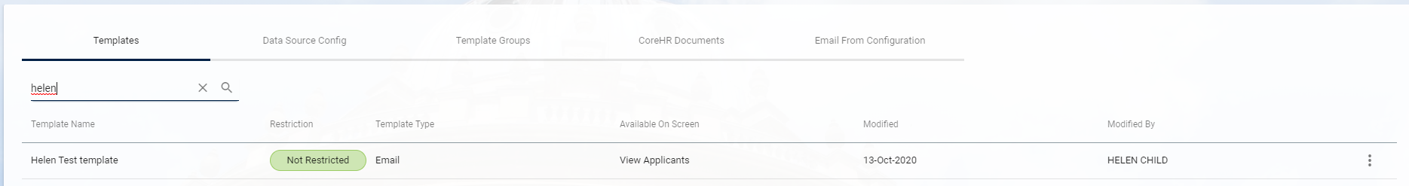

Testing
Normally the HRIS Business Analyst or HRIS Process Team would undertake user acceptance/functional testing, although this may also be done by end users depending on which groups of users will be expected to use the letter.

The HR Policy Team may also be able to assist with this.

Viewing Template settings

A copy of the document should always be stored on the shared drive. Currently these are stored in O:\PS\HRIS\Core correspondence templates.

The document template itself can't be viewed in the Portal without running it against an applicant or employee record.

To view the template configuration go to:

People Management>Data Centre>HR Admin Setup and Settings>Document and Email Templates

  - Here you can see the Template Type (1) (document or email), which screen the template can be called from (2), when it was last modified (3) and by whom (only if modified in the Portal) (4).

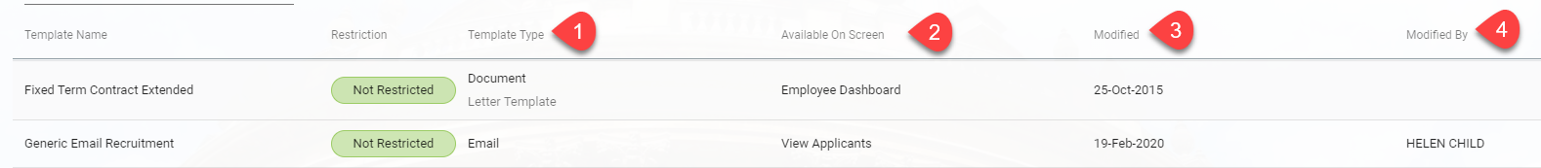

  - To view all settings, search for the template you wish to view, click on the ellipses (…) and then choose Edit.

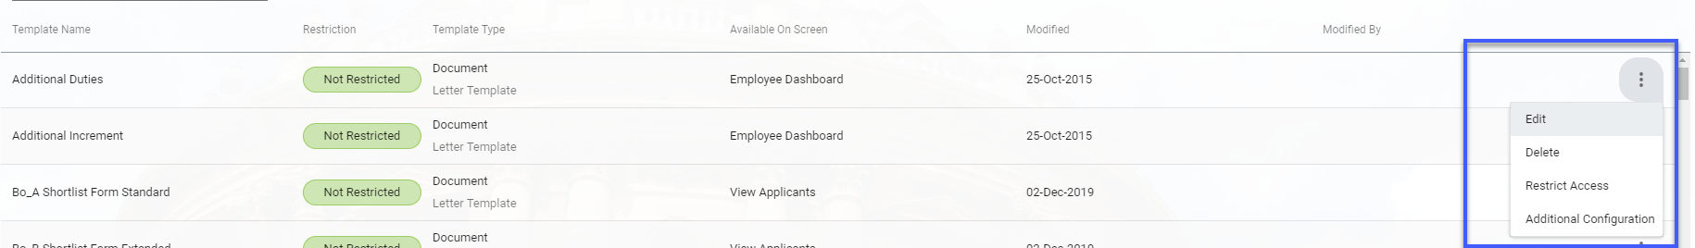

'Email From' Configuration
This is the email address that will be displayed on Recruitment emails generated by a user. Changes should only be required in this section if a new email account is created for sending emails. The current address for Recruitment emails is as shown below:

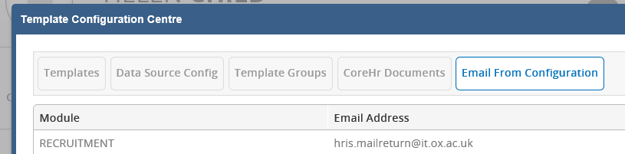

Removing Templates

You can remove a letter type in certain circumstances. For example:
- A document template has been created in error
- A new version of the document has been uploaded

People Management>Data Centre>HR Admin Setup and Settings>Document and Email Templates

The Template Configuration Centre opens:

  - Choose or search for the template to be deleted and click on it to select.

  - Click on the ellipses (…) and choose Delete. A pop-up message will appear confirming that the document has been deleted.

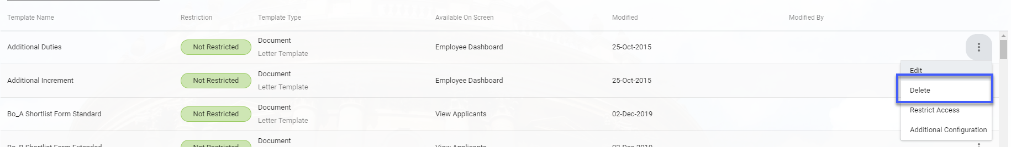

 | NB: there is no second chance when deleting a template so it is essential to be absolutely sure that you are deleting the correct template/version.

B: Updating an existing document template

Editing the Word template

  - Save a copy of the current template in the WIP folder and make the changes required.

  - Once you are ready to test the document upload it to a test environment following the steps in section 5.

  - Once testing is completed repeat the same steps in UOXP

Amending templates in the Portal

11.1. Amending a document template

People Management>Data Centre>HR Admin Setup and Settings>Document and Email Templates

Note: we have not yet tested whether an existing template can be edited successfully or if a new template should be created.

The Template Configuration Centre opens:


    - Search for the document template to be amended

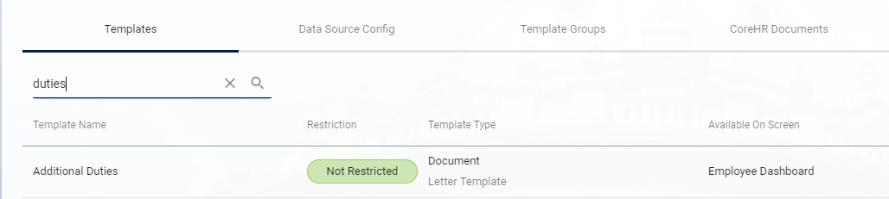

    - Click on the ellipses (…) and choose Edit

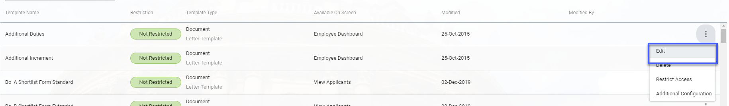

11.2. Amending an email template

People Management>Data Centre>HR Admin Setup and Settings>Document and Email Templates

    - Search for the email template to be amended.



    - Click on the ellipses (…) and choose Edit.

    - Make the required changes and save.

Archiving a document template.

When an existing document template is updated, the previous version should be kept for future reference.

  - At the end of the file name add 'Retired MMM/YY'.

  - Save the retired version in the Archive folder under O:\PS\HRIS\Core correspondence templates\V26

  - Save new template in the Current templates folder.

Maintaining the Change-Update Requests log
All changes should be recorded on the 'change_update requests' log. The log is saved in the same place as the template files under O:\PS\HRIS\Core correspondence templates. There are several tabs contained in the file:

Change Log - records the history of the changes made to each document.

Change Requests - used to record changes that have been requested but not scheduled.

In progress - can be used to record the progress of ongoing changes if desired.

Merge fields and prompts - lists all of the Merge fields, prompts and fill-ins for each document. If you make any changes to any of these you must also update the details on this tab.

Adding Security Options (optional - not currently in use)
It is possible to apply security to letters via the use of Letter Groups. Letter Groups are linked to back office screens to further control how these are made available to end users. Before security can be applied Letter Group needs to be created.

To do this go to Core Personnel>Reference>Reference K-P > Letter Group Codes. Once created the code can be linked to Reference> Letter Module > Form Option Maintenance. Core HR will need to do further work to associate the Letter Group with a Data Source.

For more information please refer to:
http://learningcentre.corehr.com/pluginfile.php/2441/mod_page/content/18/2.1.2%20Creating%20a%20Letter%20Group%20Edit.mp4

C: Raising a change request

Before publishing the new template or letterhead, you should raise a change request. See below for the relevant text to insert in the change request, dependent on the scenario.

New or amended document template
Please complete all 14 sections below.

1. Details - What is changing?
[Enter details]

2. Justification - Why is the change necessary?
====

3. Related Changes - Are there dependent changes?
====None

4. Impact on dependent services? What is the impact on connected or downstream services or components?
====No impact on services.

5. Impact - Specify downtime or at risk period
====None

6. Impact - Effect of not applying the change?
====

7. Risk Assessment - What are the risks to the services?
====None

8. Testing - Who will test it and how?
====The HRIS Analyst will amend the existing/create a new template and test it in a suitable test environment on at least two PCs and with multiple letter heads.

9. Implementation Plan - Who will implement it and how?
====The new template will be uploaded to UOXP by the HRIS analyst.

10. Communications Plan – Who needs to know and how?
====The departmental users will be notified that the new template is available, usually via the monthly bulletin.

11. Business Owner/Approver
===Susanne Hemmerich

12. What is the potential security impact of the change?
=== None. Access to the data is controlled via existing COREHR user access roles and this will not be changing.

13. How will the security impact be tested?
===not applicable (see answer to 12 above)

14. Back Out Plan - How will it be backed out in the event of the change failing?
====The old template will be retained and can be restored if necessary or if a new template fails this can be removed from the system or amended if a fix can be applied.

Tasks
Update the template as required
Upload the template in a test environment and test on at least 2 different PCs/versions of Word
Upload the template in the live environment and test on at least 2 different PCs/versions of Word
Update the Change_Update request document which can be found here - O:\PS\HRIS\Core correspondence templates

New or amended letterhead
Raise a change and enter the details below [Clone change 20007031]:
Type = Standard
Justification = Document
Short Description = Change request: Letterhead template for [insert department]

Please complete all 14 sections below. [Clone change 20007031]

1. Details - What is changing?
[Enter details here e.g. department relocated, change of details such as phone number or email address.]

2. Justification - Why is the change necessary?
====The current letterhead displays an incorrect address for the [insert] department.

3. Related Changes - Are there dependent changes?
====None

4. Impact on dependent services? What is the impact on connected or downstream services or components?
====No impact on services.

5. Impact - Specify downtime or at risk period
====None

6. Impact - Effect of not applying the change?
====The letterhead will continue to display the department's previous address, which may cause confusion.

7. Risk Assessment - What are the risks to the services?
====None

8. Testing - Who will test it and how?
====The HRIS Analyst will amend the existing letterhead and test it in a suitable test environment with a variety of letter templates and at least two PCs.

9. Implementation Plan - Who will implement it and how?
====The HRIS Analyst will provide the new letterhead document to the department via the HRIS support desk.

10. Communications Plan – Who needs to know and how?
====The department will be provided with the new letterhead when it is ready for use.

11. Business Owner/Approver
===Susanne Hemmerich

12. What is the potential security impact of the change?
=== None. Access to the data is controlled via existing COREHR user access roles and this will not be changing.

13. How will the security impact be tested?
===not applicable (see answer to 12 above)

14. Back Out Plan - How will it be backed out in the event of the change failing?
====The old letterhead will be saved in the Archive folder at O:\PS\HRIS\Core correspondence templates\Archive, and can be restored if necessary.

Tasks
Format the letterhead as necessary and create the header bookmark (and footer if required)
Test the letterhead against a selection of documents – min. 1 change letter, 1 offer letter and 1 other (exc. contracts and forms as these have University header or none).

D: Resolving issues within the templates

- The letter templates can be quite difficult to work with and the slightest change can affect the output of the letter and how the merge fields, fill-ins and ASK fields function.

- Formatting can be affected by things outside our control such as local PC settings, versions of Microsoft and the departmental header being used.

- In the event of a macro not working as expected on one document which is working correctly on another document, compare the two documents and check for extra or missing characters, spaces, and punctuation in the macro code.

Department header appearing on every page

  - Does page 2 onwards have a page number in the top left of the page? If No – copy from another template. Save and test.

  - Check the formatting of the header. Go to Page Layout>Page Setup>Layout. Check that the ‘Different first page’ box is ticked.

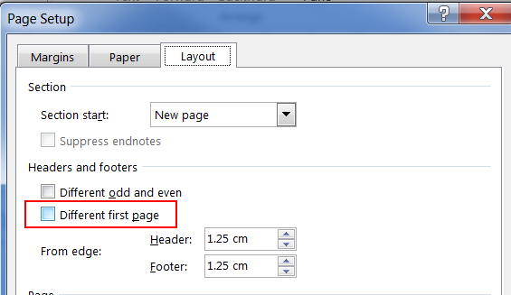

Extra spacing between rows or paragraphs
Formatting in MS Word is often determined by local settings on your PC. Regardless of the settings applied to a document these can be overridden by the default settings on a user’s PC. Formatting is based on best endeavours and there is an expectation that departments will need to check and amend formatting on documents produced from the system.

  - Check the paragraph settings on the Page Layout tab. If document has spacing set after the line this may be the cause. Try removing it and running the letter again. Ensure that Spacing After is set to 12pts.

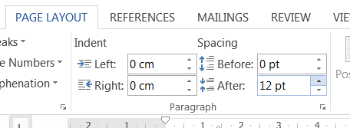

  - Check how many carriage returns there are between the rows/paragraphs. Adjust as required.

  - If it’s a merge field, check the actual data that is being merged. If the field allows manual entry (e.g. the Job Text field), then it could be an extra space or return in that particular field on the record you are running the letter for.

No spacing between paragraphs

  - Check the paragraph settings on the Page Layout tab. Ensure that ‘Spacing_After:’ is set to 12pts.



Avoid using carriage returns to create spaces between paragraphs, as this can affect the Widow/Orphan control and may result in a heading being on a different page from the rest of the text.

Department header not appearing

The macros that control the inclusion of headers and footers is based on whether there is anything in the field already. Documents that have the University Logo in the header e.g. contracts will not also pull in the departmental header.

  - Check whether there is a space or carriage return in the document header. If yes – remove it and test again. If no – check that the correct macro is saved against the document. See Section 2.2 for guidance on the macros for Headers and Footers.

Prompts, Fill-ins and merge fields

Prompt does not appear as expected

ASK response does not return data as expected

D: Creating or amending departmental letterheads

Each Department has their own standard letterhead. A copy of all departmental letterheads are saved in O:\PS\HRIS\Core correspondence templates\v20\Current letterheads\Final versions for go-live.

The third-party software Aspose, which is used to perform letter generation, does not always fully support MS Word functionality, therefore formatting may not always behave as expected.

In order for the departmental letterheads to appear correctly in the templates, a number of changes are required in the departmental letterhead document. For example you may need to add tables and copy text and images into the table for headers and footers to ensure that text and positioning on the template is correct after the mail merge is performed.

All changes to departmental letterheads must be thoroughly tested to ensure that the mail merge text and formatting are correctly displayed in the final output.

In order for the Macros to run bookmarks must be created for the header and footer.

  - Open the letterhead document.

  - Save a copy of the letterhead into the folder and add WIP to the end of the file name.

  - Click on the header and ensure you have selected the entire contents of the header.

- Navigate to the Insert menu from the ribbon and Choose Bookmark.  A pop-up window will open. | 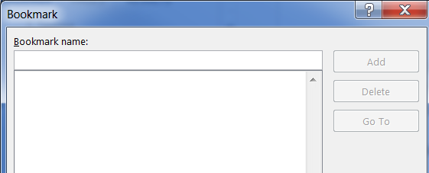
- Enter “header1” in the Bookmark name field and click Add.  The pop-up window will close. | 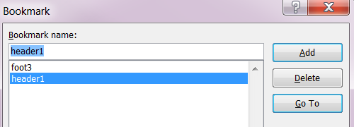

  - If applicable, repeat the process above for the footer and name the bookmark “foot3”.

  - Click Save and close letter head document.

